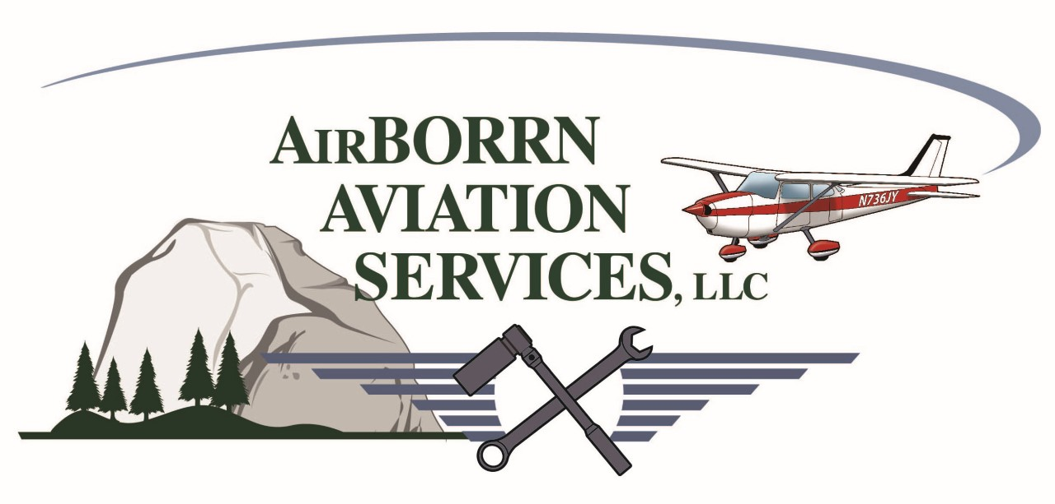

Private Pilot Flight Training Course (MPI)

(Minimum Requirements)
40 hours –Total
20 hours—Flight training
10 hours—Solo
3 hours—Flight training cross-country
5 hours—Solo cross-country
3 hours—Flight test prep
3 hours—Night
3 hours – Instrument training

40 Hours Aircraft - Cessna 172M

(Pricing based on $2000.00 block purchase rate.)

Flight Training

20 hours dual flight training $4,000.00
20 hours solo flight $2,700.00
25 hours of pre-flight & post-flight ground instruction briefings $1,625.00
Basic training materials including knowledge course & syllabus $ 750.00
Written exam $ 150.00
FAA practical test–(check-ride) Examiner Fee ($600.00) & 3 hours A/C Rental $1,005.00
_____________________________________________________________________________________
Total $10,230.00

Aircraft Rental = $135.00/hour. Ground/Flight Instructor (CFI) = $65.00/hour

NOTE: National Average for Private Pilot training is between 55-85 hours.

