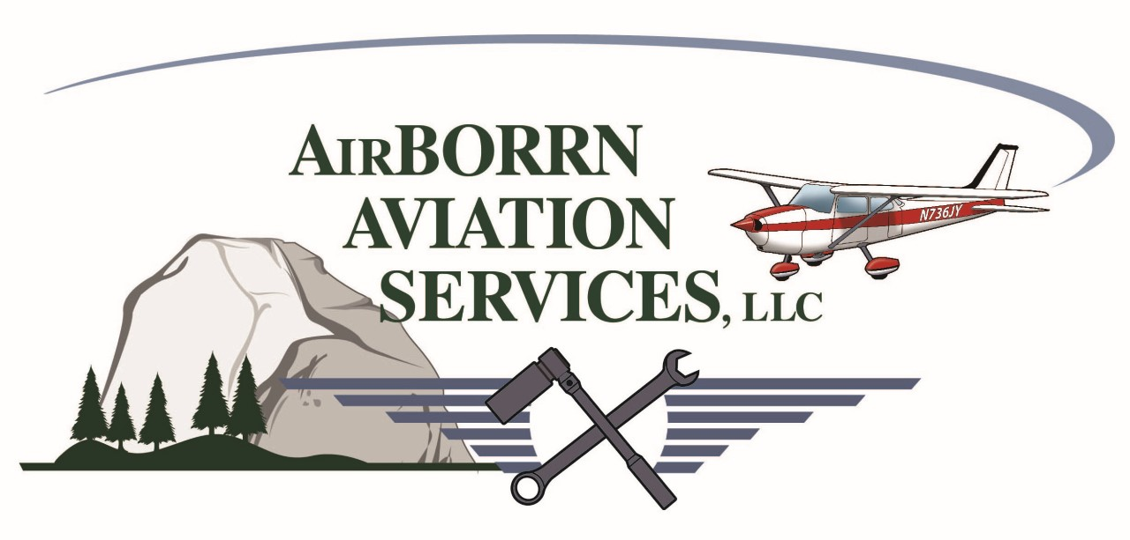

Mariposa/Yosemite (MPI)
Flight Training / Aircraft Rental Rates (Wet)

Cessna 172M $145.00/hour
(*) Cessna 172M $135.00/hour
Cessna 150L $125.00/hour
(*) Cessna 150L $115.00/hour
Mooney M-20F Executive $175.00/hour
Beechcraft Baron D55 Multi-Engine (M.E.) $385.00/hour

Certified Flight / Ground Instructor (CFI/GI) $65.00/hour
CFI/GI Training-- Customer Aircraft $75.00/hour
CFI/GI Training--Next GEN/High Performance/M.E. $85.00/hour

Flight Review (BFR) Min 2.0 hours (CFI) $140.00

(*) $2,000.00 Block Purchase Rate
Phone (209) 966-2143 Email: airborrnaviation@gmail.com Web www.yosemiteaviation.com

