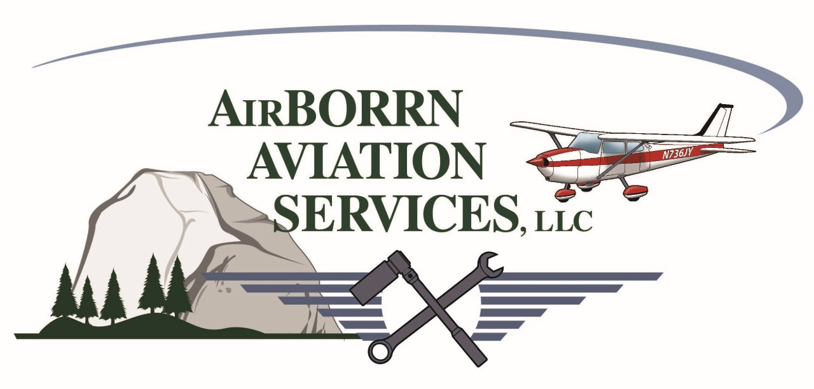

Mariposa/Yosemite (MPI)
Flight Training / Aircraft Rental Rates (Wet)

Cessna 172M $160.00/hour
(*) Cessna 172M $150.00/hour
Cessna 182H $195.00/hour
(*) Cessna 182H $185.00/hour
Mooney M-20F Executive $185.00/hour Ground Instructor (CFI/GI) $75.00/hour
CFI/GI Training-- Customer Aircraft $85.00/hour
CFI/GI Training--Next GEN/High Performance/M.E. $95.00/hour

Flight Review (BFR) Min 2.0 hours (CFI) $170.00

(*) $2,000.00 Block Purchase Rate
Phone (209) 966-2143 Email: airborrnaviation@gmail.com Web www.yosemiteaviation.com

